**RESUME**

**Puneeth.M.Bhat**

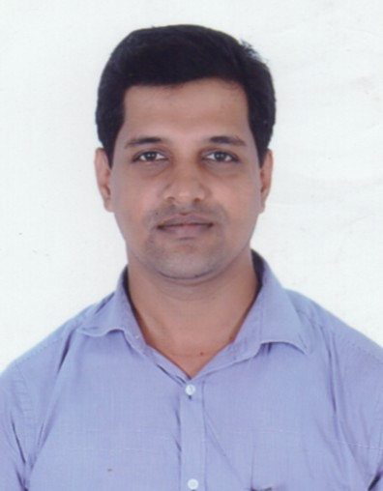

D/No 9-128/1

“Vishwas”, Kuntalpady

Shakthinagar

Mangalore-575016

Karnataka

Mob-9886748162

Puneethm1982@gmail.com

###### Career Objective:

To work towards accomplishing the best in terms of productivity in a customer oriented industry by motivating people in doing things right, be able to set benchmarks for others to follow and also to gain relevant industrial exposure so as to grow career-wise.

**Strength:**

Go getter, Flexible and Versatile team player, willing to take on Challenging roles & Tough assignments, Excellent Interpersonal skills, People Management, People Motivation and Proactive Decision-maker.

###### Professional Competencies:

* High Organizational Skills.
* Good Listener and Communicator.
* Can work as a Key Member of a Team.
* Commitment to Personal and Professional Growth.
* Presentation and Training Skills.
* Maintaining better Customer Relationship.
* Dedication and Hard Working.
* Excellence in Target Settings.

**Professional Experience:**

###### :

EXIDE LIFE

Working as Senior Territory Manager from 30/06/2014.

Job description:Handling co-operative channel with team of sales officers.

HDFC LIFE Pvt.Ltd., Mangalore.

Sales Manager

09-05-2009 – 27-06-2014

I I had grown from Sales Development Manager to Sales Manager over last 5 years. I have total seven years experience in this industry.

Responsibilities:

* Handling an independent Financial Consultant and Business Leaders.
* Continuously Driving & Ensuring Recruitment of Financial Consultants and Good Licensing Management to Build the Strong Distribution Base.
* Drive Various Contests & Initiatives of the Company to Enhance the Business.
* Joint Field Work with Finacial consultant for Business & HNI Case Closings.

ICICI PRUDENTIAL LIFE INSURANCE

FINANCIAL SERVICE COSULTANT

From 06-08-2007 TO 30-04-2009

Joined as a Financial Service Consultant Banca assurance department with ICICI Bank as partner.

**Responsibilities:**

* Building good relationship with Bank staffs(I-Bank)
* Selling Insurance product to Bank customer.
* Providing continuous support to bank staff to achieve revenue targets.
* Self lead generation through walk-in customer and achieving targets.

**HBL** **GLOBAL** **PVT** **LTD**

**From 2005 to 2007**

Joined as Sales Executive of Personal Loan product of HDFC BANK and promoted as team leader in

Two years period.

**Personal details**

* Name : Puneeth.M.Bhat
* Date Of Birth : 04th September 1982
* Gender : Male
* Languages known : English, Kannada, Malayalam, Hindi, Tulu.
* Hobbies : Reading, Listening to Music, Agriculture and travelling.
* Address : D.No.9-128/1

Vishwas Kuntalpady,

Shakthinagar

Mangalore-575016

###### Academic Qualification:

|  |  |  |  |
| --- | --- | --- | --- |
| **Examination Passed** | **Institution** | **Year Of Passing** | **Percentage Obtained** |
| **SSLC** | M.S.C.H.S Neerchal,  Kasaragod,Kerala | April 1999 | 58% |
| **PUC** | Tagore college,Calicut University. | September 2002 | 48% |
| **B.B.M** | Vivekananda College,Puttur | April 2004 | 61% |

The information furnished above is true to the best of my knowledge and belief.

**Place: Mangalore Regards**

**Date**:

(**Puneeth.M.Bhat)**